Red Ribbon Week

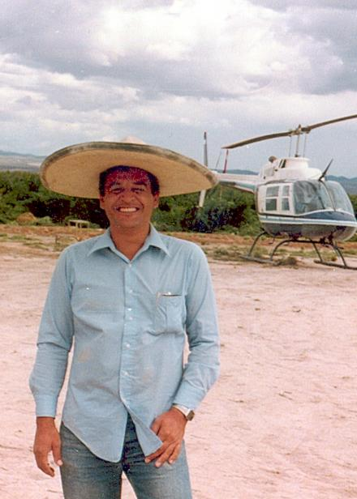

Enrique (Kiki) Camarena was a Mexican-American man working for the DEA after serving in the Marine Corps, being a fireman, police officer, and deputy sheriff in California. While on assignment in Mexico for four years, he was on the trail of the country’s biggest marijuana and cocaine traffickers. He was getting close to exposing a multi-billion dollar drug pipeline in 1985, until he was kidnapped that February. He was headed to lunch with his wife when he was last seen being thrown into a van by masked men, his body wasn’t discovered until a month later.

After his death, “Camarena Clubs” were launched in his hometown of Calexico, California. Hundreds wore red ribbons and pledged to lead a drug-free life in his honor. Then President Ronald Reagan was in office, so club members presented a proclamation to First Lady Nancy Reagan which brought it national attention. The campaign became official in 1988 by the National Family Partnership with President Reagan and “Just Say No” creator Mrs. Reagan as honorary chairpersons. Red Ribbon Week is celebrated annually from October 23-31st.

Check out this Google Earth video on “The Life of DEA Special Agent Kiki Camarena”.

Sources & Resources:
- DEA
- Fairfax CSB Opioid Info
- REVIVE Training for Opioid Overdoses
- Medication Disposal
- Teen Substance Use
- FCPS Substance Abuse Prevention Program
- DEA Drug Take Back Day

For general questions about the FCPS Substance Abuse Prevention Program, please contact the Office of Student Safety & Wellness at: (571) 423-4270 and be sure to follow us on Twitter at @FCPSSAPS.
For further Information & support:
Michael McNulty
Substance Abuse Prevention Specialist
mpmcnulty@fcps.edu

